Day – 4
Component-Specific Troubleshooting Practical
1.Open your desktop or laptop, locate the RAM slots, and remove and re-insert the RAM module to simulate reseating then document each step you took and any issues you observed during the process.
RAM Reseating Procedure
Objective
The purpose of this activity is to locate the RAM slots, remove the RAM module, and carefully reinsert it. This process is called reseating RAM and can help fix problems caused by a loose or poorly connected memory module.
Important: Before opening a computer, always shut it down completely and disconnect it from the power source.
Steps I Took
Step 1: Shut Down and Disconnect Power
I completely shut down the computer and disconnected the power supply. For a laptop, I also made sure the charger was unplugged.
Why?
This prevents electrical damage and reduces the risk of injury while handling internal components.
Step 2: Open the Computer
I carefully opened the desktop case/laptop back panel using the appropriate screwdriver.
Step 3: Locate the RAM Slots
I identified the RAM module and RAM slots on the motherboard. RAM is usually a long, narrow circuit board held in place by clips on both sides.
Step 4: Remove the RAM Module
I carefully released the retaining clips and gently removed the RAM module by holding it from the edges.
Important: I avoided touching the gold contacts because dirt or static electricity can cause connection problems.
Step 5: Inspect the RAM and Slot
I checked the RAM module and slot for:
- Dust or dirt
- Physical damage
- Loose connections
Step 6: Reinsert the RAM
I aligned the notch on the RAM module with the correct position in the RAM slot. Then, I pressed the module firmly and evenly until it was properly seated and the retaining clips locked into place.
Step 7: Reassemble and Test
I closed the computer, reconnected the power, and started the system to confirm that it booted correctly.
Conclusion
RAM reseating is a simple troubleshooting procedure used when a computer has memory-related problems. Removing and properly reinserting the RAM can restore a loose connection between the RAM module and the motherboard, helping the computer complete the POST (Power-On Self-Test) and start normally.

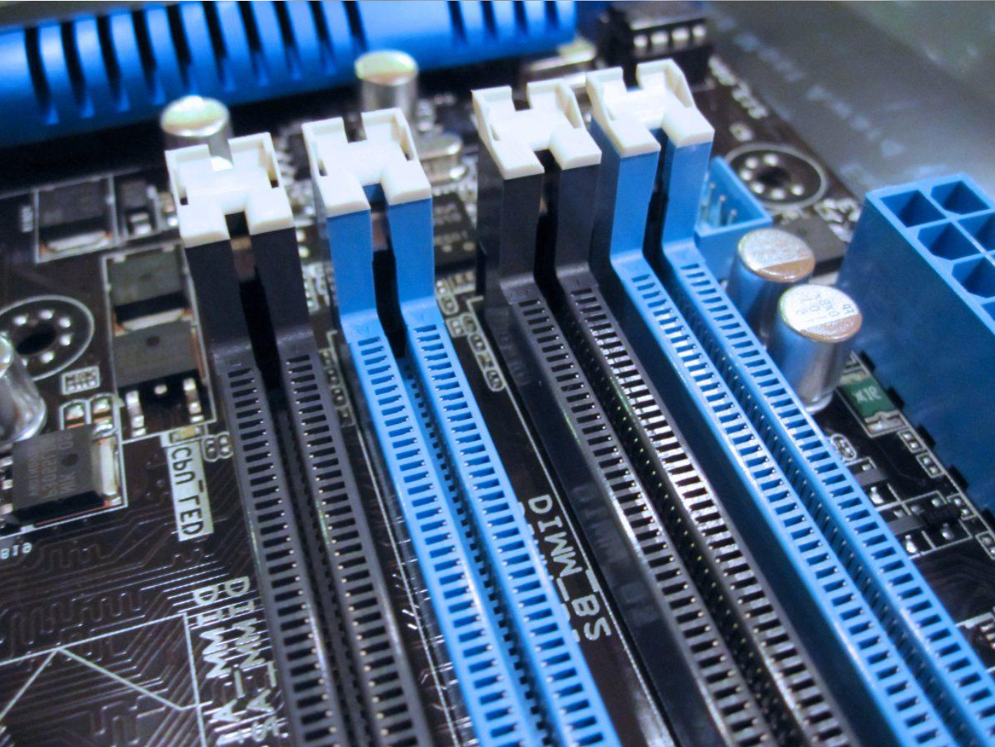

2.Create a troubleshooting checklist for diagnosing a faulty GPU in a gaming PC, including at least 5 steps from initial symptom identification to confirming the fix.<br><br><em><strong>Hint:</strong> Think about display issues, driver checks, and physical connections.</em>
Troubleshooting Checklist for Diagnosing a Faulty GPU in a Gaming PC
A GPU (Graphics Processing Unit) is responsible for processing and displaying graphics, especially in games. If a GPU develops a problem, the computer may show display errors, poor performance, or may not display anything at all.
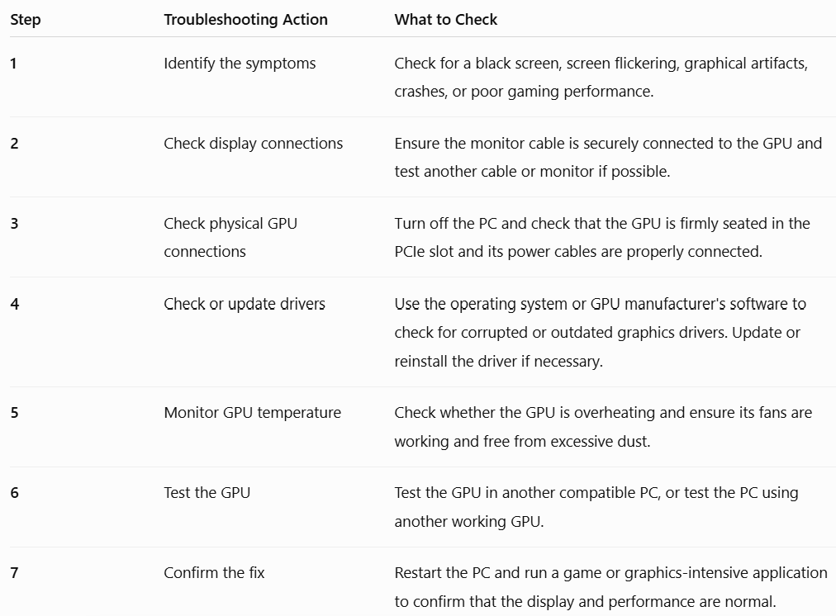

Step-by-Step Explanation
1. Identify the symptoms:
First, observe the problem. Common signs of a faulty GPU include a black screen, flickering display, coloured lines or dots (artifacts), game crashes, and unusually poor graphics performance.
2. Check display connections:
Make sure the HDMI or DisplayPort cable is securely connected to the graphics card, not loose or damaged. Testing another cable or monitor helps determine whether the problem is caused by the display equipment rather than the GPU.
3. Check the physical GPU installation:
Turn off the computer and disconnect the power. Open the case and check that the GPU is properly seated in its PCIe slot. Also check that all required PCIe power connectors are firmly connected.
4. Check the graphics drivers:
A display problem is not always caused by faulty hardware. Outdated or corrupted drivers can cause crashes or graphical problems. Updating or reinstalling the graphics driver may solve the issue.
5. Check temperature and cooling:
Make sure the GPU fans are spinning correctly and that excessive dust is not blocking airflow. Overheating can cause the GPU to reduce performance or crash during gaming.
6. Test the GPU:
To confirm whether the GPU itself is faulty, test it in another compatible computer or install a known working GPU in the original PC.
7. Confirm the fix:
After making the necessary repair, restart the PC and test it by running a game. If the system displays graphics normally without crashes, overheating, or artifacts, the problem has likely been resolved.
Conclusion
A systematic troubleshooting process helps determine whether a graphics problem is caused by the GPU itself or by another component, such as the monitor, cable, power supply, drivers, or cooling system. The final test using a game or another graphics-intensive application helps confirm whether the issue has been successfully fixed.

3.Simulate a storage issue by unplugging and replugging a SATA or NVMe drive (SSD/HDD) on a test system, then describe the error messages or BIOS indicators you see before and after reconnecting.
Simulating a Storage Drive Issue
Objective
The purpose of this activity is to understand what happens when a computer cannot detect its storage drive, such as a SATA SSD/HDD or an NVMe SSD.
Important: This procedure should only be performed on a test system. Always shut down the computer and disconnect the power before removing or reconnecting internal hardware.
Procedure and Observations
Step 1: Shut Down the Computer
I completely shut down the test computer and disconnected it from the power source before working with the storage drive.
Step 2: Disconnect the Storage Drive
I opened the computer and disconnected the storage drive.
- For a SATA drive, this may involve disconnecting the SATA data cable and/or power cable.
- For an NVMe SSD, the SSD would be carefully removed from its M.2 slot.
Step 3: Start the Computer Without the Drive
After disconnecting the drive, I started the computer and checked the BIOS and boot screen.
Possible observations:
- The SSD/HDD does not appear in the BIOS storage or boot device list.
- The system may display an error such as:
“No Boot Device Found”
“Boot Device Not Found”
“Reboot and Select Proper Boot Device”
This happens because the computer cannot find the drive containing the operating system.
Step 4: Reconnect the Storage Drive
I shut down the computer again, disconnected the power, and carefully reconnected the storage drive. I ensured that all cables or connectors were firmly connected.
Step 5: Start the Computer and Check Again
After reconnecting the drive, I started the computer and checked the BIOS.
Expected observation:
- The storage drive appears again in the BIOS storage information or boot device list.
- The operating system starts normally because the computer can now detect the drive.
Before and After Reconnecting the Drive
Condition | BIOS/Boot Indicator
Drive disconnected | Drive may not appear in the BIOS; the system may show “No Boot Device Found.”
Drive reconnected | Drive appears in the BIOS again, and the computer can boot normally.
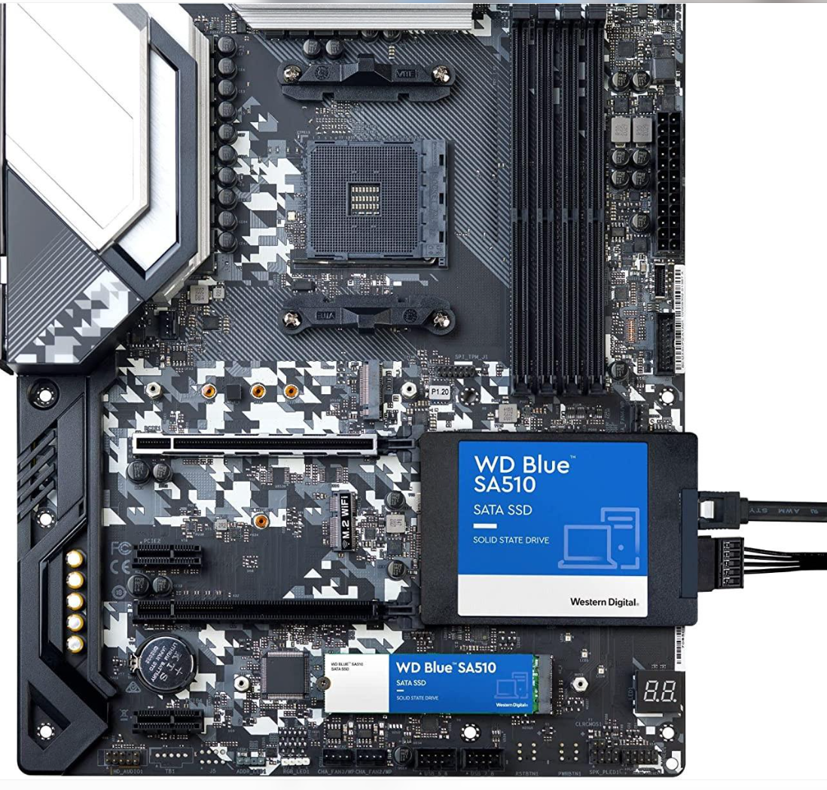
Conclusion
Disconnecting the storage drive simulates a common hardware problem where the computer cannot detect its SSD or HDD. Before reconnecting the drive, the BIOS may show that no storage device or boot device is available. After securely reconnecting it, the drive should be detected again and the computer should boot normally
4.Given a scenario where a PC randomly restarts, list which component (RAM, GPU, storage) you would check first and explain your reasoning, then outline the specific diagnostic steps you would perform for that component.
Troubleshooting a PC That Randomly Restarts
1. Which Component Would I Check First?
I would check the RAM (Random Access Memory) first because faulty or improperly connected RAM can cause system instability, unexpected restarts, freezing, and blue screen errors.
RAM temporarily stores the data required by running programs. If the RAM is defective, the computer may not process data correctly, which can cause the system to crash or restart unexpectedly.
2. Diagnostic Steps for Checking RAM
Step 1: Check for Error Symptoms
Observe whether the computer frequently restarts, freezes, displays a Blue Screen of Death (BSOD), or crashes while running applications.
Step 2: Run Windows Memory Diagnostic
- Press Windows + R.
- Type mdsched.exe.
- Press Enter.
- Select Restart now and check for problems.
Windows will restart and test the RAM for memory-related errors.
Step 3: Check RAM Connections
Shut down the PC and disconnect the power supply. Open the computer case and check whether the RAM modules are properly seated in their motherboard slots.
Step 4: Reseat and Test RAM Modules
Remove the RAM modules carefully and reinstall them firmly. If the computer has multiple RAM modules, test one module at a time to identify whether a particular module is faulty.
Step 5: Check the Results
After testing, check whether Windows reports any memory errors. If a particular RAM module consistently produces errors, it may need replacement.
3. Other Components to Consider
If the RAM is working correctly, I would also check:
Component | Possible Problem | Diagnostic Check
GPU | Overheating or faulty graphics card | Check GPU temperature, fans, drivers and physical connections.
Storage (SSD/HDD) | Drive failure or corrupted system files | Check drive health, SMART status and Windows system logs.
4. Conclusion
I would check the RAM first because faulty memory can cause unexpected restarts and system crashes. By running Windows Memory Diagnostic, checking RAM connections, and testing individual modules, I can identify whether the memory is responsible for the problem. If RAM is working properly, I would investigate the GPU and storage drive.
Important: Random restarts can also be caused by an overheating CPU, faulty power supply (PSU), or motherboard problems. Therefore, RAM should be treated as a starting point, not the guaranteed cause.


